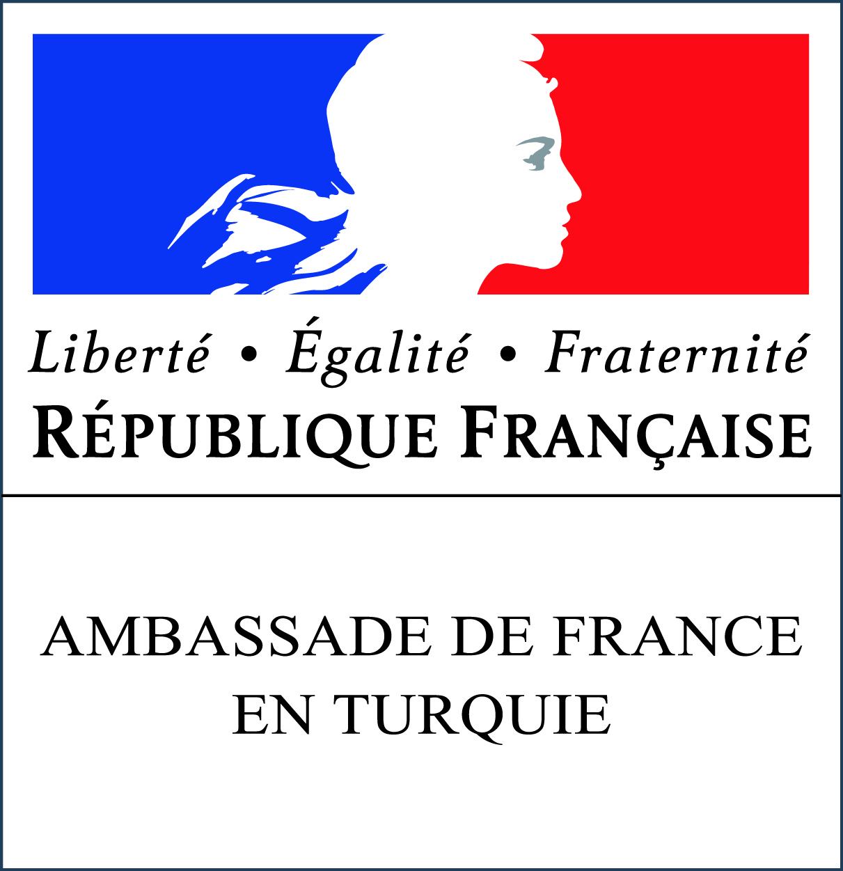
French-Turkish Research Fellowships Program
Embassy of France to Turkey
Application form
Type of fellowship you are applying to:
- PhD students
- Young visiting researchers (Submission up to 3 years after obtaining the doctorate)
- Visiting researchers

Personal and professional data
Name ………………………………………………………………………………………………………………………………………………….………………...
Surname …………………………………………………..………………………………………………………………………………………..………………...
Date and place of birth ……………………………………………………………………………………………………………………….………………...
Tel: ……………………………………………………………………………………………………………………………………………………..………………...
Email: …………………………………………………………………………………………………………………………………………………………………...
Institutional address: ………………………………………………………………………………………………………………………….………………...
……………………………………………………………………………………………………………………………………………………………………………...
……………………………………………………………………………………………………………………………………………………………………………...
Current position in your university: ……………………………………………………………………………………………………………………...
Since when: ………………………………………………………………………………………………………………………………………..………………...
President’s name of department or director’s name of the laboratory of your university: ……………………………………

Previous doctoral studies (for young visiting and visiting researchers only)

Institution that delivered your PhD and date ……………………………………………………………………………………..
PhD Thesis title: ………………………………………………………………………………………………………………………………….

The project in France
Host institution in France ……………………………………………………………………………….…………………………………….
Expected dates of stay in France from …......…………………................... to ………………………………………………
You cannot be guaranteed to leave on these exact dates, depending on administrative procedures.
Research field ……………………………………………………………………………………………………………………………………..
Title of your research project ……………………………………………………………………………………………………………..
Please sum up your research project in 5 lines ………………………………………………………………………………………………………………………………………………………………………………………………………………………………………………………………………………………………………………………………………………………………………………………………………………………………………………………………………………………………………………………………………………………………………………………………………………………………………………………………………………………………………………………………………………………………………………………………………………………………………………………………………………………………………………………………………..
Have you already beneficiated of a French government scholarship in the past, if yes when ………………………………….

Please send your application to the following email address: burslar@ifturquie.org

PLEASE notify the object of your email with the type of scholarship you are applying to:
- PhD candidate Fellowship
- Young Visiting Researcher Fellowship
- Visiting Researcher Fellowship
Incomplete applications will not be considered

Application package should include:
- CV
- this application form
- A cover letter including the research project and your long term prospect in the frame of cooperation with French researchers (maximum 2 pages)
- Two letters of reference (including a letter from the Director of the Department of your current university)
- The letter of invitation from the French Research Center or University (which has to be found by the candidate and indicate clearly the dates of your stay).

*All applications should be in French or English
*Please submit your application in type written form (hand written form will not be considered).

